**Name**: Samya Sunibir Das

**ID**: 1911563642

**Course and Section**: CSE332.3

**Submission Date**: 4th November 2020

**Lab 1 Performance Tasks**

1. Complete the truth table from the manual

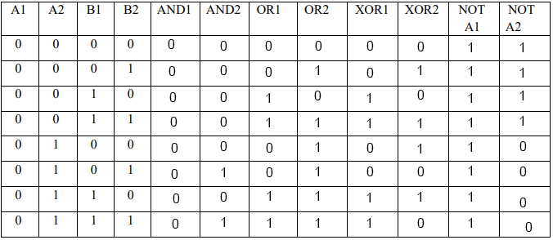

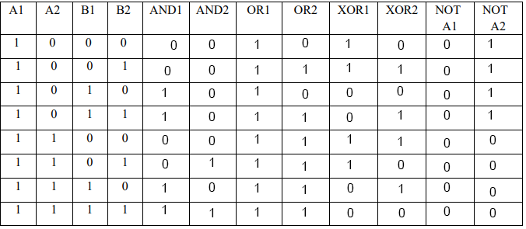

1. Discussion about the topics covered in Lab 1

In the first lab class, we were demonstrated how to design a 2-bit Logic Unit, which was a part of an ALU, in Logisim with the help of built in tools available in the software. The circuit was designed using AND, NOT, OR, XOR gates and Multiplexers. Which led to an in-depth discussion about multiplexers on how they basically work, their real-life applications, and how they were implemented in this particular experiment. We have learnt that multiplexers act as a multiple-input and single-output switch. As for multiplexers’ real-life applications, we were informed that vending machines and ATMs were built with these. The multiplexers in the design were given A1,B1,A2,B2 as inputs connected through the 4 types of gates as previously mentioned and both of the multiplexers returned single outputs each. Finally, the multiplexers were both connected with a selection line s1s2. After finishing the design, we were also shown how to design subcircuit in Logisim as well. We were also informed of enable lines in digital logic designing, which basically controls the outputs of logic gates.

On the later part of the class, the class concluded by a detailed introduction on how github works, how to use it and git command line to share/host resources on the platform. We learnt about some of the basic commands and the instructor told us to explore further if we were interested.